|  |  |  |
| --- | --- | --- |
| **forgiveness** | | |
|  | |  |
|  |  |  |
|  |  |  |
|  |  |  |
|  |  |  |
| **kindness** |  |  |
|  |  | **thankfulness** |
|  |  |  |
|  |  |  |
|  |  |  |

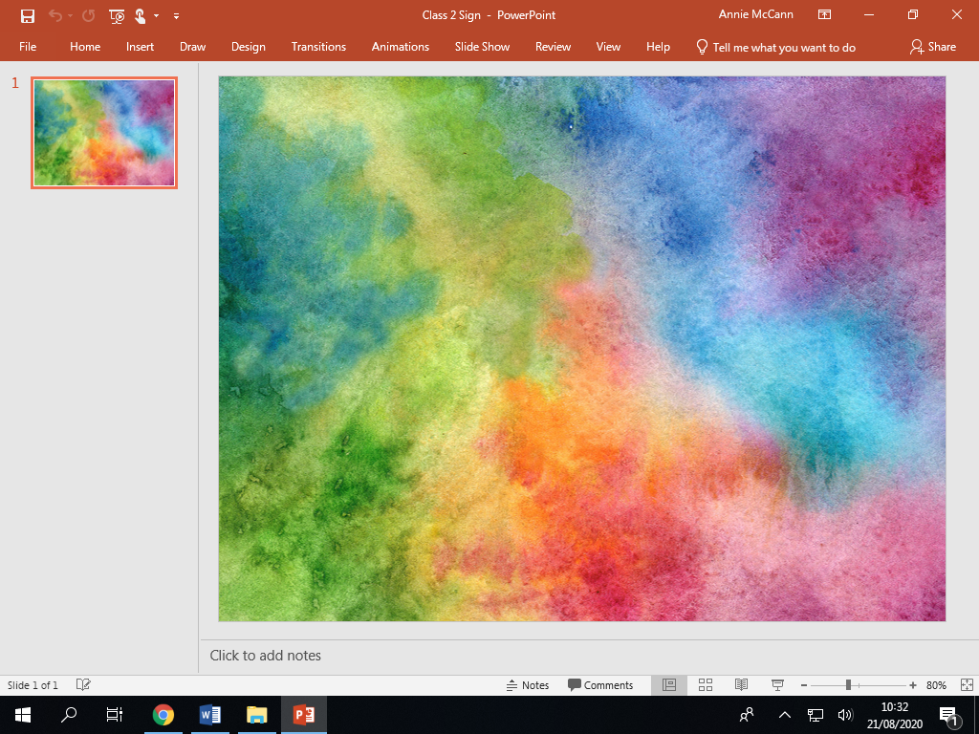

The emphasis is on positive action (**recognition and reward**) rather than negative action (**punishment**). Problems which occur are dealt with constructively.  Four kinds of discipline are needed to implement this positive approach:

|  |  |  |
| --- | --- | --- |
| **EXPECTATIONS** | **VISIBLE CONSISTENCIES** | **RECOGNITION** |
| Respect  Love  Achieve | Daily meet and greet  Persistently catching children doing the right thing  Picking up on children who are failing to meet expectations  Accompanying children to the playground at the end of every day  Praising in Public (PIP), Reminding/Reprimanding in Private (RIP)  Consistent language from adults in school | Verbal praise  Stickers  Dojo points linked to Visible Learning characteristics (10 dojos = 1 token)  Recognition boards  House Tokens  Certificates  Phone call home  Notes/ Postcards home  House Rewards  Show work to another adult  Recommendation to Headteacher  Meritorious Pupil Book  Headteacher Award |

|  |  |
| --- | --- |
| **PREVENTATIVE DISCIPLINE**  **Clear expectations** about learning  Attractive classrooms and general surroundings with **communication friendly displays**  **Meeting the needs** of pupils  Setting aside an area for ‘**time out**’ as required  Well trained school staff who **know and understand the children** in their class  School Leaders who **model expectations** with both rewards and sanctions  **SUPPORTIVE DISCIPLINE**  **Following up a disruption later** when the ‘heat’ has subsided (not keeping pupils IN at break/lunch unsupervised)  **Re-establishing a relationship** after correcting a pupil  Developing a ‘**behaviour ‘contract’** with a pupil (and parents/carers)  Applying a ‘**team’** approach and seek **support from other school staff** | **CORRECTIVE DISCIPLINE**  **What** to say when a child isn’t completing as task or is disruptive  **Deliberately ignoring** some behaviours  Casual or **direct questioning on learning** NOT behaviour  A **simple, discreet warning**  Defusing potential conflict  **Re-stating school’s expectations** and values  Giving **simple choices** (do this now or we will have to talk about it at break)  **Taking a pupil aside** from the group (not sending out)  Using **directed ‘time out’** |
| **SELF-DISCIPLINE**  Pupils taking **responsibility for their own actions**  ‘**Community service’** and other sanctions which reinforce collective responsibility or the need for reparation or compensation  Through **1:1 and individualised inclusion plan (IIP)** setting own targets for improved behaviour |

**truth**

**compassion**

**peace**

**love**

**hope**

**generosity**

**respect**

**justice**

**gentleness**

**honesty**

**courage**

**humility**

**friendship**

**service**